Overview Sheet

Date: 9/24/15
Name: Nate Foss, Alex Hoganson
Research Topic: Etch-A-Whiteboard

Illustration(s)
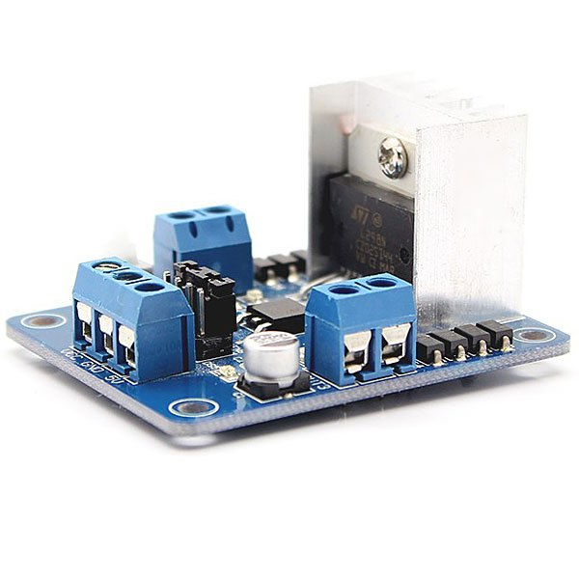

General Description
L298N Motor Driver Controller Board Module for DC and Stepper Motors

Key Features
Motor driver, motor controller board module
Controls 2 DC motors or one stepper motor
Driver: L298N Dual H Bridge
Drive part of the operating current Io: 2A

Pros
Can handle enough current
Appears simple to use
$3.12 + free shipping

Cons
Would need to get two

Specifications
Motor driver, motor controller board module
Controls 2 DC motors @2A max per DC motor, or one stepper motor
Driver: L298N Dual H Bridge
Driven part of the input voltage Vs: 5V~35V (or 7V~35V depending on power supply needs)
The logical part of the work current is 0~36mA
Drive part of the operating current Io: 2A
Maximum power dissipation: 20W (T = 75 degree Celsius)
Control signal input level: High level 2.3V <= Vin <= Vss; Low: -0.3V <= Vin <= 1.5V

Additional Notes
No bad reviews, everyone has been satisfied.

Full APA Citation
http://www.gearbest.com/development-boards/pp_22490.html?currency=USD&gclid=Cj0KEQjwvo6wBRCG3Zv92ZSLlIYBEiQA5PLVAt045AV7lsBhEt1p2Ghbq16PEwsYRL0obAWChao2ehUaArhd8P8HAQ

